**Incline Elementary School: 2023-2024**

**Welcome to grade 5!**

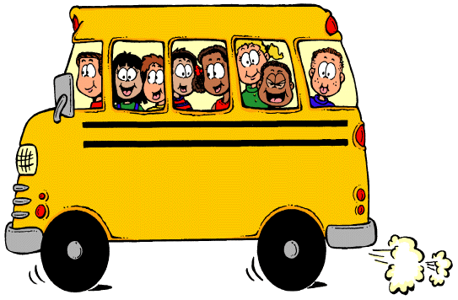

***To Bring to School Every Day***

* Backpack
* Binder (supplied by the school)
* Lunch or lunch money or complete Free and Reduced Meal waiver
* Appropriate outdoor clothing (snow pants, jackets, gloves…)

***Classroom Supplies for the First Day of School***

* Package of 24 #2 pencils (pre-sharpened please)
* 1 ream of graph paper (1cm not smaller and not pad of paper please)
* 1 bottle white glue
* Box of tissues – no aloe or lotion please
* 1 box gallon zip lock bags

***Personal Supplies for the First Day of School***

* 1 set of headphones or earbuds (MUST HAVE)
* 1 box of colored pencils (12-24)
* Hand held pencil sharpener (optional)
* 1 small container (pencil box) for personal supplies - with student’s name on it

***School Fees***

Here is our school fee structure. Please make checks payable to “Incline Elementary School”:

|  |  |  |
| --- | --- | --- |
| Technology Fee | Provides your student with access classroom technology | $20 |
| Classroom Fee | Provides your student with additional classroom supplies and activities | $40 |
| **Total School Fee\*** |  | **$60** |

|  |  |  |
| --- | --- | --- |
| 5th Gr. Activities* | Science and Social Studies Field Trips such as winter exploration, ropes course/team building, research boat trip, Spooner Lake, Carson City (weather permitting for each), sweatshirts and end of year activities | **$170**  (payment plans available) |

* Fees may be waived for families qualifying for Free and Reduced Meal plans. Please come to the main office to complete your FRM forms.

**Have a fantastic school year!**